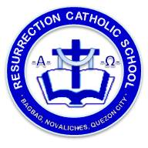
Resurrection Catholic School
S.Y. 2017 - 2018

BUDGET OF WORK IN CLE 5

QUARTER: 3rd Quarter UNIT TOPIC: I Love Others The Way Jesus Does
No. of days: 21 Days

TIME FRAME | Lesson Topics | PAGES
4 days | - I Love My Parents | 118 – 129
4 days | - I Respect Life | 130 – 139
4 days | - I Respect Marriage and the Family | 140 – 149
4 days | - I Respect the Good of Others | 150 – 161
4 days | - I Respect the Good Name of Others | 162 – 171
1 day | - Performance Task

Prepared by: Approved by:

Maria Anita B. Agulto Miss Meddy L. Sanchez
CLE Teacher School Principal, RCS

